Shanti Shahi's devotion for Rajpur CLC

Shanti Shahi has been working as Social Mobilizer in Rajpur CLC since 2006. She holds position of Secretary in CLC Management Committee and she is also working as facilitator for a FSP class since 2013. She is enjoying teaching school dropouts and out of school children in village through FSP class organized by CLC and gaining different experience. She loves to teach mathematics. She is serving as trainer for different training programs particularly for DEO organized training programs such as training for CLCMC, literacy facilitators, supervisors etc. Managing home and taking care of family members is her regular duty. She also manages some time to update information in her face book. This way, she has busy schedule in her life these days. So, she bought a scooter 18 months before to make her travel easier. She gets very less salary for being Social Mobilizer. However she could earn additional income from training programs and FSP class. She could support her family in constructing a new house, which is on the way to CLC. She is happy and satisfied with her work and her effort for uplifting CLC. Through her 8 years experience in CLC, she became more confident in planning and management of different programs. So, she is working for her own CLC although she got job offer from other organizations.

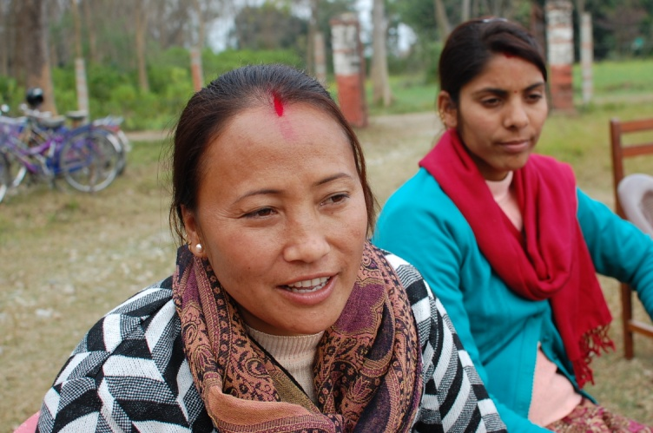
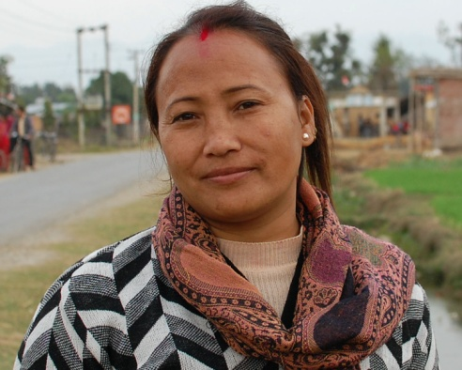
Last year, Rajpur CLC got opportunity to implement Literate Nepal Mission (LINEM) in Shivapur VDC. She was the main responsible person on behalf of CLC for LINEM. She served as resource person for trainings of literacy volunteers, became member of village level education committee, and took charge of overall supervision and implementation of the program. So, she was very busy with LINEM last year. And she will be busy this year too to implement the LINEM in her own VDC Rajpur. Her effort and dedication towards her responsibility is highly appreciated by DEO Kapilvastu. NRC-NFE is proud to have such devoted and committed personnel in CLC which is promoted by NRC-NFE with the support of NFUAJ.

