Siddhipur
Durga Laxmi's Life of Difficulty
Earthquake is a natural disaster which unfortunately took place on April 25 2015 in Nepal. It has effected many people's life in the affected areas and so the life of people in Siddhipur. Around 10 people died and 900 houses were fully damaged by the earthquake.
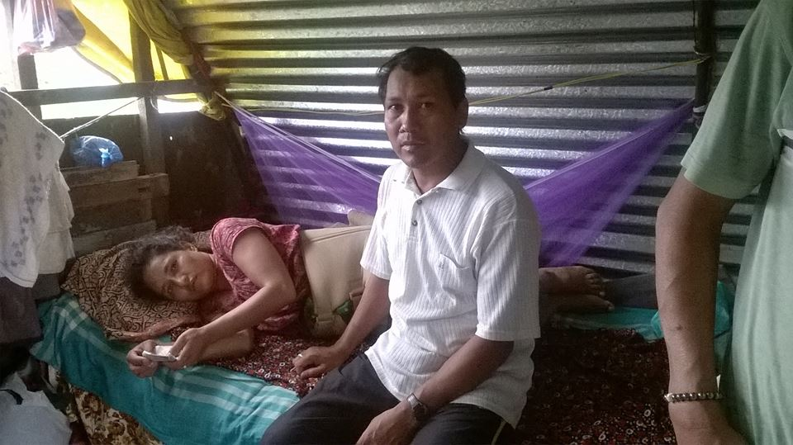
Shiddhipur CLC is helping the community families in need utilizing resources from different donors and supporters. The CLC helped in relief distribution program, managing temporary shelters and planning for rebuilding of community households. Initially it undertook a household survey in coordination with the VDC now Municipality to find out the situation and conditions of the earthquake victims.
The CLC found out Ms. Durga Laxmi living at Durghat, Siddhipur as one of the serious victims of earthquake. Even before the earthquake occurred, she was living a misery life after her husband's bike accident and became unable to work. Since then she had been looking after her family and taking care of her children's studies and holding the expenses by herself.
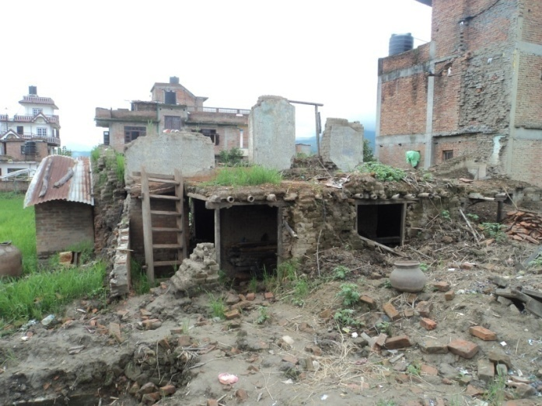
The CLC volunteer felt very sad when she told her bad experience in earthquake. She was trapped in her destroyed house while trying to save her father-in-law. She shouted for help but nobody listened. She thought she was going to die. But at last, she was rescued from the broken house and took her to the hospital. Her back bone was broken and bleeding was continuing. So her health was very bad. She could come back from the hospital only after two months.
Durga Laxmi's fully damaged house

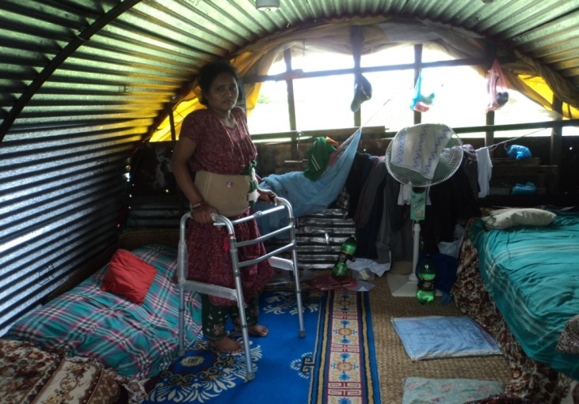
With the help of NRC-NFE, our CLC supported to construct a temporary house in a rented land. Six members of her family are living together in the shelter. The temporary house provided safe shelter for them during the rainy season and made their life easier to some extent. They still got problems of living and eating together in such a small space of the shelter. Yes, it is not sufficient support for them, however it is being managed by them.

