Nepal Post Earthquake Relief Project 2015-17
Quarterly Report
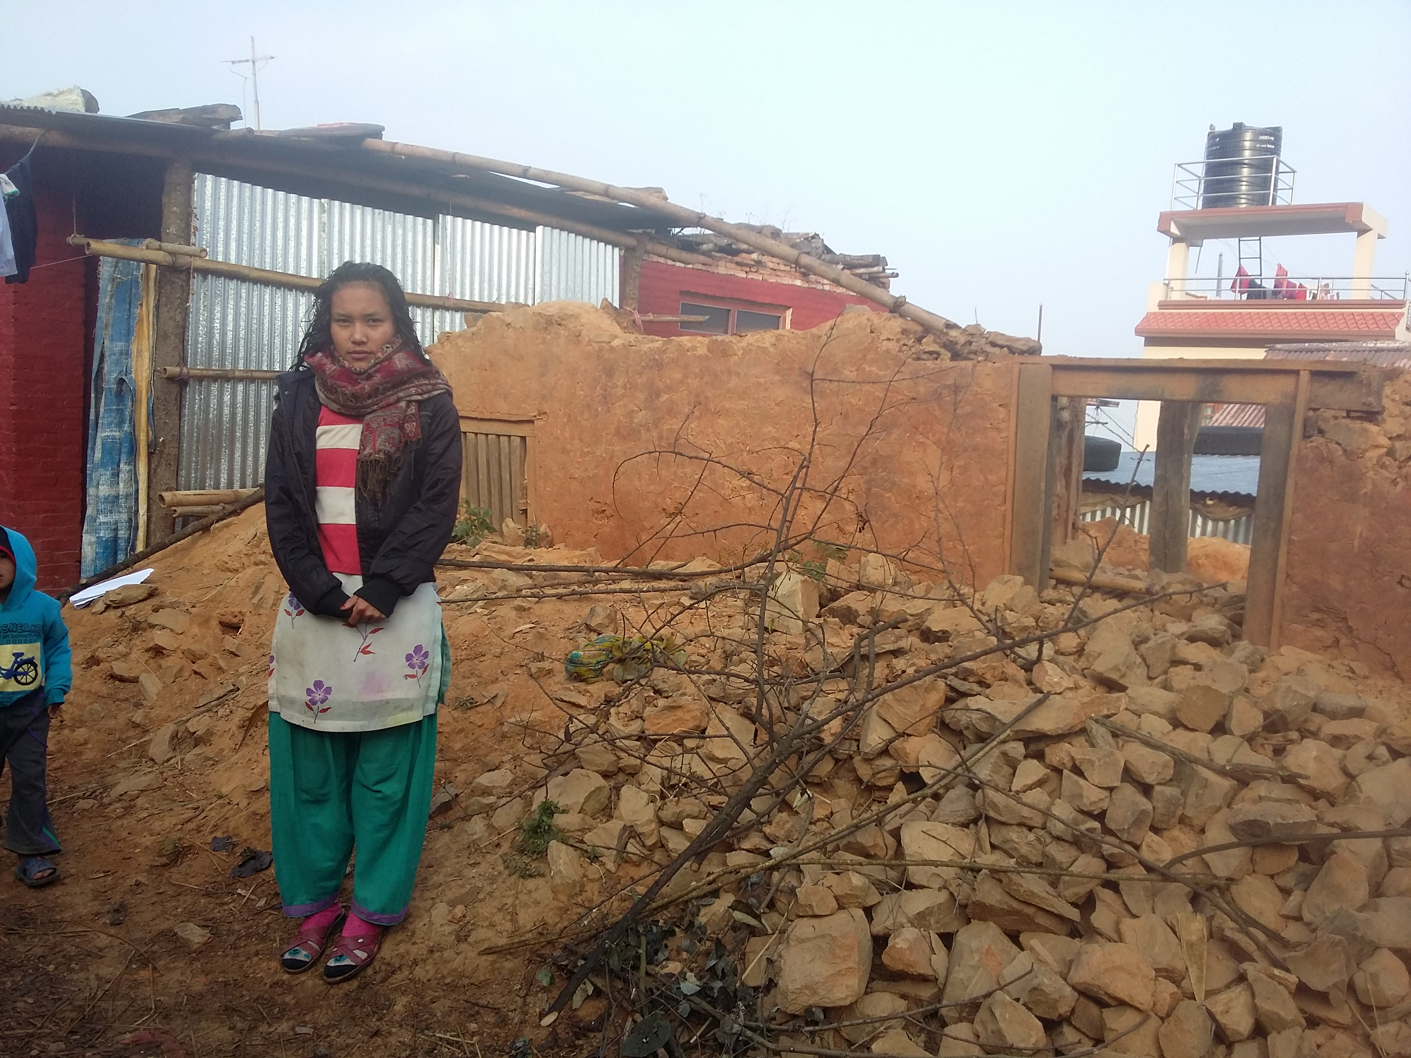
November 2015-February 2016

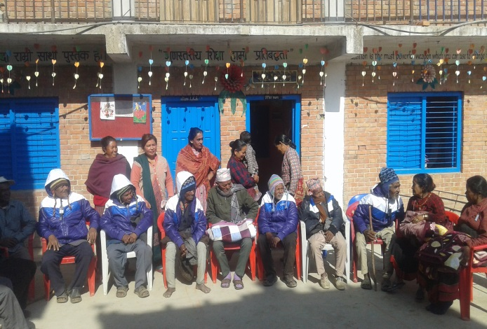

Submitted to:
National Federation of UNESCO Associations in Japan

Submitted by:
National Resource Center for Non Formal Education
March 2016
Nepal Post Earthquake Relief Project 2015-17
Quarterly Report
November 2015 - February 2016

Background
Two huge earthquakes on April 25 and May 12, 2015 at magnitude of 7.9 and 7.4 have been affected mostly in 14 districts of Nepal. Kathmandu valley was hit badly. The CLC areas of the Kathmandu Valley where we have been supporting Siddhipur, Amarapur (Bungamati), Kumbheshwor of Lalitpur district and Chittapol of Bhaktapur district were also badly affected.

In that context, NRC-NFE, Nepal has established "Earthquake Relief Fund" to support the earthquake victims in its project areas. Firstly, NRC-NFE conducted need assessment of the affected 4 CLC areas. Based on the needs identified, NRC-NFE had distributed relief materials, tents/ tarpaulin and equipment for clearing debris and supported for building temporary shelters to needy people. Those post-earthquake relief activities were based on immediate needs of the victims. But the victims needed support for long run.

Accordingly, NRC-NFE had proposed "Nepal Post Earthquake Relief Project 2015-17" to National Federation of UNESCO Associations in Japan (NFUAJ). In order to implement the project, an agreement between NRC-NFE and NFUAJ was made on 1st November 2015. As mentioned in the agreement, this report is prepared and submitted to NFUAJ, which covers progress from November 2015 to February 2016.

Objectives of the project:
The project was implemented with the following objectives
  - Supporting those who have been affected by Nepal Gorkha Earthquake occured in April 2015.
  - Providing necessary equipment to community people for restoration of disaster affected areas through 4 CLCs (namely Amarapur, Siddhipur, Kumbheshwor and Chittapol).
  - Providing trainings and workshop necessary for earthquake victims for their rehabilitation.
  - Providing scholarship for the most needy families who have school going children
  - Constructing new CLC building and repairing damaged CLCs for their future activities.
  - Establishing mutual understanding between the beneficiaries of Nepal Post Earthquake Relief Project and supporters in Japan.

The project has focused on the following activity areas in order of achieving its objectives.
- Support to community people for rehabilitation
- Training and counseling for community
- Scholarship for most needy families
- CLC construction and repairing

Activities undertaken so far under the project
Preparatory activities
The first planning meeting among the four CLCs was organized on 8 October, 2015 at NRC-NFE to discuss about the Nepal Post Earthquake Relief Project. The meeting started with orientation of the project activities and implementation strategies along with role of NRC-NFE and CLCS. The CLCs prepared draft action plan of the project during the meetingbased on the needs of respective areas.The meeting also compiled the updated data information on effect of earthquake in the CLC areas as follows:

CLC | Death | Injured | Houses destructed
Amarapur | 7 | 34 | 799
Siddhipur | 11 | 10 | 869
Kumbheshwor | - | - | 59
Chittapol | 1 | 10 | 650

Moreover, series of meetings were organized with the CLCs to finalize the CLC action plans. The finalized action plans of the CLCs are given in Annex 1.

- Support to community people for rehabilitation

1.1 Zinc sheet for roofing of houses
As many houses were damaged and badly affected in CLC areas, the earthquake victims need support for rebuilding their shelters. So, as per project plan, zinc sheets were distributed to needy families for roofing their houses. For this, NRC-NFE developed the guidelines and background information collection form for selecting needy victims. Accordingly, the CLCs selected the needy victims and the CLCs with the support of project, purchased required number of zinc sheets and distributed to the families. After getting the sheets, most of the victim families used the sheets for repairing the roofs of their houses and some have used to build temporary shelters.

CLC wise number of families benefited and number of zinc sheets distributed
CLC | No of families benefited | No of sheets distributed
Amarapur | 15 | 22.5 bundles | 135 sheets
Siddhipur | 17 | 22.5 bundles | 135 sheets
Kumbheshwor | 5 | 6 bundles | 36 sheets
Chittapol | 23 | 30 bundles | 180 sheets
Total | 54 | 81 Bundles | 486 sheets

Community people happy to receive zinc sheets
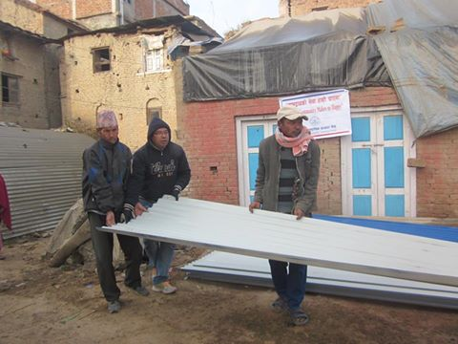  Receiving zinc sheet by selected families in Siddhipur CLC | 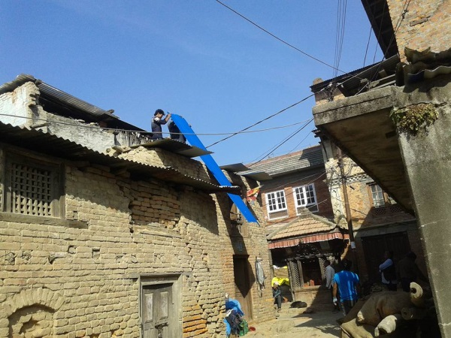  Use of zinc sheet for roofing the destroyed houses in Amarapur
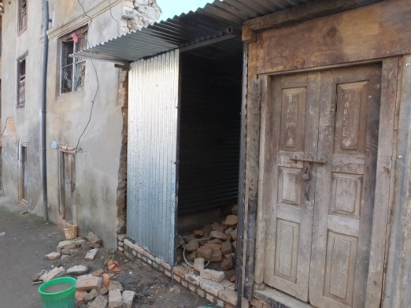  Fixed zinc sheet in Kumbheshwor | 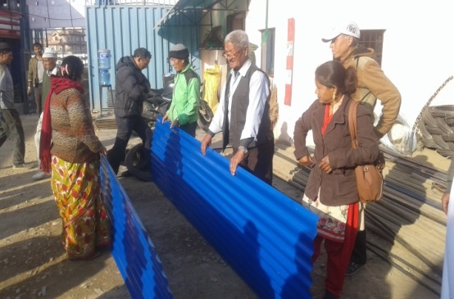  Victim families receiving zinc sheet in Chittapol CLC

  - Drinking water facilities through water reservation tanks
In order to support for drinking water facilities, project provided five water tanks of different sizes as per need and demands of CLCs as follows.
CLC | Tanks provided | Installed at | Target beneficiaries
Siddhipur | 2 of 1000 liters each | CLC building | CLC visitors and community
Kumbheshwor | 1 of 5000 liters | Imukhel,  near CLC | Imukhel consumers’ group
Chittapol | 2 of 1000 liters each | CLC building | CLC visitors and community
Total | 5 tanks of total 9000 liters

The CLCs and the consumers’ groups have been using the tanks for water reservation and providing drinking water facility to the community people of the respective areas.
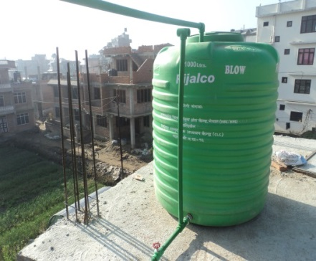 | 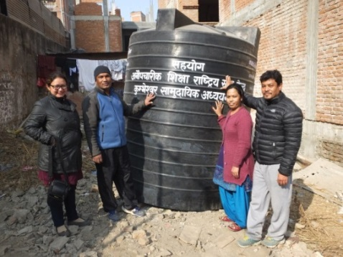 | 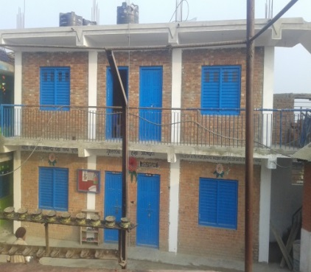
Siddhipur | Kumbheshwor | Chittapol

  - Medicines, health equipment and stretchers for CLCs
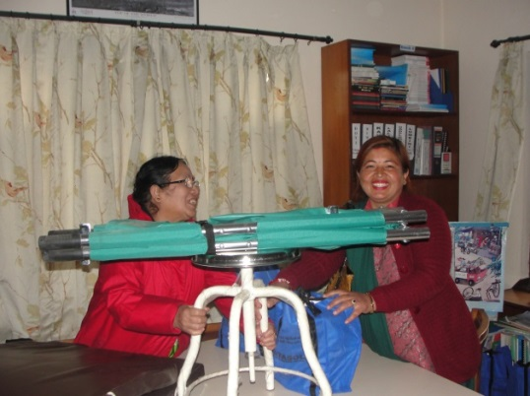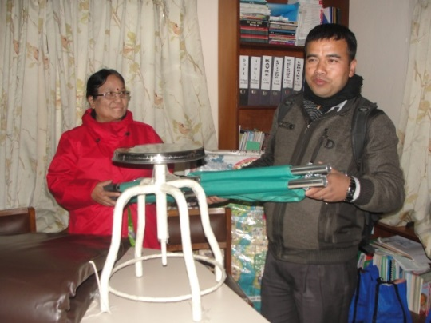In order to provide health services to the victims of the community people, CLCs demanded the medicines and health equipment. Accordingly, three CLCs were equipped with stretcher, folding table cum bed and auto-scope. Those equipment are being utilized by the CLCs for health camps and other regular health services.
Hand over of health equipment to the CLCs

List of health equipment provided to the CLCs
CLC | Auto Scope | Stretcher | Folding Table
Amarapur |  | 1 | 1
Chitapole | 1 | 1 | 1
Shiddhipur |  | 1 | 1

  - Equipment for debris clearance
As per the demand of Amarapur CLC and Chittapol CLC to settle the debris in respective CLC areas, equipment like wheel barrel, shovel, pick and helmets were provided to them. The community people have been utilizing the provided equipment continuously to clear and settle the debris. List of equipment provided is given in following table.
CLC | Wheel barrel | Shovel | Pick | Helmet
Amarapur | 10 | - | - | -
Chittapole | 10 | 20 | 20 | 30

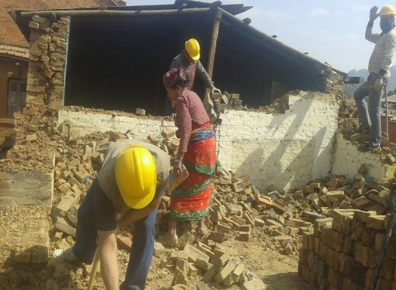 | 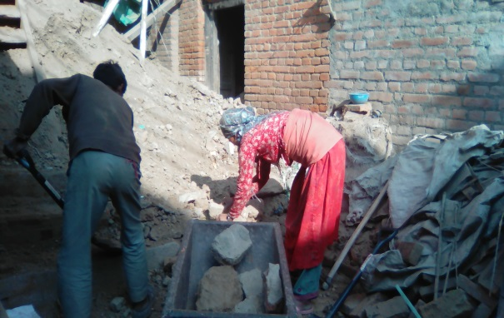
Use of equipment to clear debris at Chittapol and Amarapur CLC.

- Training and counseling for community people
2.1 Training on chlorine production using Standard Wata
Training on Chlorine production using Standard Wata device was organized on 12 December 2015 with technical support of Environmental Camps for Conservation Awareness (ECCA), Nepal with participation of 22 persons from CLCs and NRC-NFE. The participants of the training were CLC managers, social mobilizers/ volunteers and school students from 4 CLCs and NRC-NFE staff. The resource persons of the training were Ms. Manisha Godar and Shailina Sthapit from ECCA. Major contents discussed in the training were :

- Sources of water
- Different water borne diseases
- Role of chlorine solutions in water disinfection
- Introduction of Wata and its applications
- Chlorine making process
- Methods of testing of chlorine and chlorinated water
- Marketing skills
- Follow up action plan

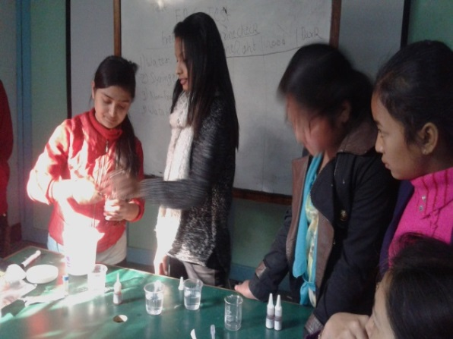 | 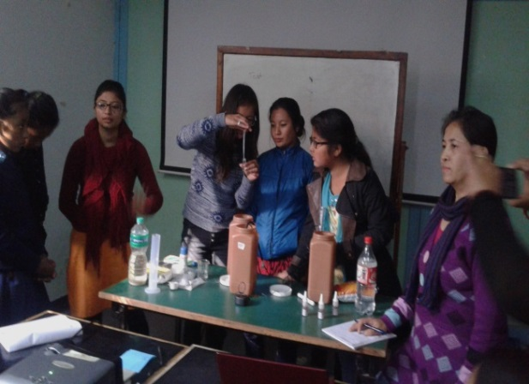
Demonstration and practice of Chlorine Production using Standard Wata

Schedule and the list of participants of the training is given in annex 2.

After the training program, the CLCs are producing chlorine (watasol - water purifying liquid) with the purpose of using it for purifying drinking water and distributing safe drinking water through existing water distribution channel. For that, the project provided the devices to each of the 4 CLCs and also organized an orientation program for the CLCMC members and Managers to instruct them about the device and chlorine production technique along with distribution process.

The CLCs now started producing chlorine (Watasol) using Standard Wata and utilizing it for purifying the drinking water for community people. This will be continuous activity of the CLCs to serve community people. NRC-NFE has recommended them this kind of production based and service oriented activity could be an example of social business.

  - Counseling for victims
Two days Training for Trainers (TOT) on counseling was organized on 30-31 Dec 2015 at NRC-NFE with participation of 24 persons. The participants of training were CLCMC members and volunteers from 4 CLCs. The resource persons of the training were Mr. Shiddhi Bahadur Bajracharya and Ms. Palistha Sikharakar from ECCA. The major contents of the training were introduction of counseling, counseling methods, counseling activities and role and responsibilities of the CLCMC. At the end of training, participants discussed about the follow up activities for community counseling. The major contents, schedule and participants are given in Annex III
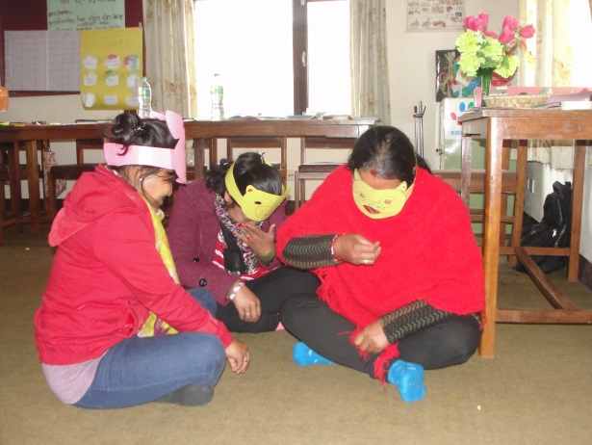  Role Played in the training activity | 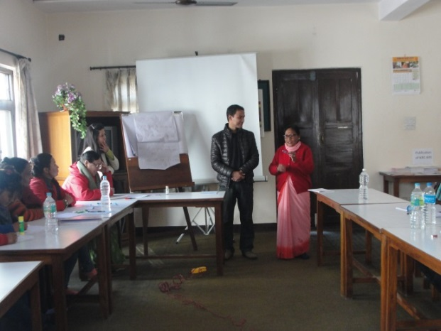  Presentation of group discussion

  - Vocational training/ support for income generation for those who lost their job after earthquake
In order to provide vocational training or support for income generating activity for those needy persons from victim families, who lost their job after the earthquake and needs to start new business for income, this program was planned under the project. For identifying the needy persons, NRC-NFE developed guidelines with selection criteria and background information collection sheet. Analysing the information sheets, the CLCs identified the most needy persons. The vocational training and income generation activities proposed by the needy persons are as follows:

Amarapur CLC | Siddhipur CLC | Chittapol
Tea shop  Sewing and cutting | Tailoring  Handicraft  Shoes making  Animal farming | Sewing and cutting training and tailoring

  - Awareness program on Disaster Risk Reduction (DRR)
Awareness on DRR, preparedness and rescue is very important knowledge and information to the community people who are suffering from 2015 earthquake in Nepal. In order to provide knowledge and skills on awareness building, one day Training of Trainers was organized on 21 December 2015 at NRC-NFE for 18 CLC personnel from 4 CLCs including NRC-NFE staff. The resource person of the training was Mr. Nirakar Joshi from National Society for Earthquake Technology (NSET). Training presentation was focused on earthquake risk reduction, preparedness and rescue. During the training, the participants also discussed on different awareness raising activities to be organized at community level. As a follow up action of the training program, the CLCs prepared detail action plan of awareness raising activities for different target groups and those programs will be organized accordingly. The schedule, contents, participants and activities action plan of each CLCs are given in Annex IV

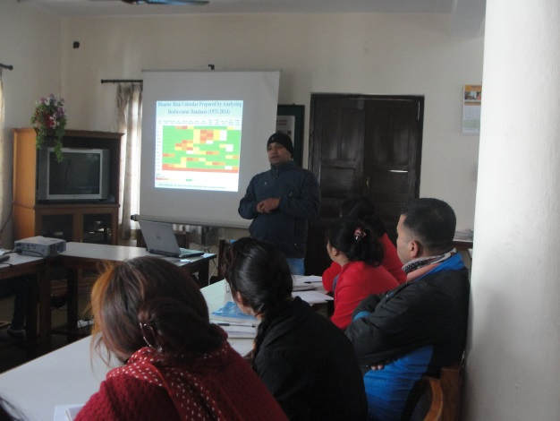  Presentation on earthquake risk reduction and preparedness by NEST | 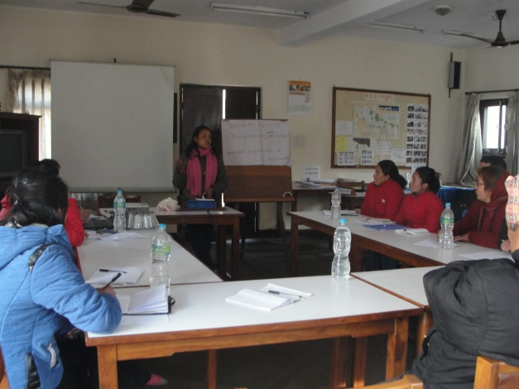  Presentation on primary health service by Red Cross

For organizing varieties of awareness raising activities and counseling activities for community, NRC-NFE produced earthquake related different informative materials as booklet, poster, video (earthquake risk reduction and preparedness) in coordination with the NSET and distributed to each CLC.

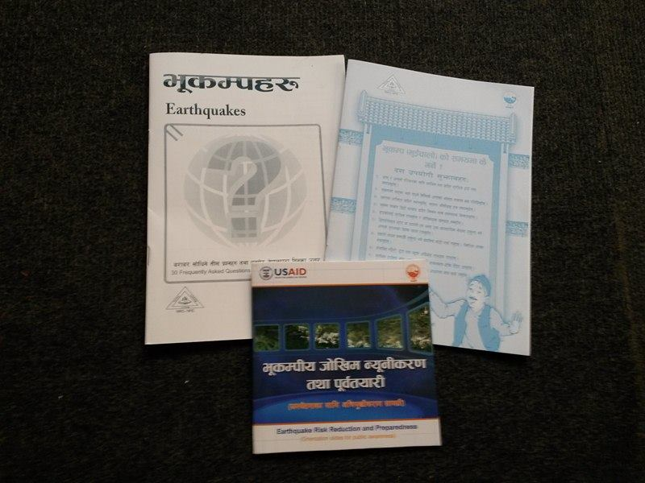 | 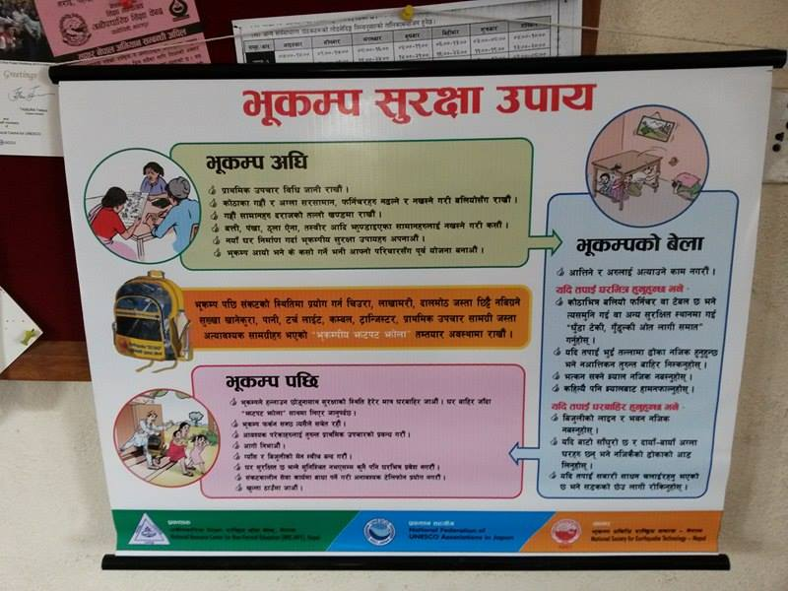
Earthquake related informative materials collected and reprinted

  - Trainings for Post Legal Documents Preparation, Administrative Process
Different information regarding grants and other facilities for earthquake victim was collected. Based on the information, CLC will disseminate the updated information to the community people. The CLCs started to provide Help Desk Services to the needy people. There is no clear cut policy prescribed by the government. The government implemented some grant distribution activities like grant of Rs.15,000 for temporary shelter for victim families and Rs.10,000 to purchase warm clothes for each victim household. The CLCs had helped needy innocent victims in getting victim ID cards and receiving those grants.

- Scholarship for most needy families
In order to support victim families for their children's education, scholarship program was planned. NRC-NFE developed guidelines with criteria for selecting scholarship program beneficiaries and information collection sheet of the selected children for scholarship.
The basic criteria for selecting children were:
- Orphan children
- Children of injured or disable parents
- Jobless parents/ low family income
- Parents unable to pay school fees
- Drop out children
- Family members whose houses were damaged and badly effected
- Family living in temporary shelter like tents, huts
- Students not going to school after earthquake
- Stopped going to school and started to work to earn some money
- Other specific conditions (if any)
After collecting all documents with background information of selected children from respective CLCs, NRC-NFE analyzed the information. Based on the analysis, scholarship amounts were allocated and remitted to each of the CLCs. As per needs of the selected children, it was decided to provide scholarship for school fee for 15 months and amount for educational materials, uniform and tiffin for 12 months starting from November 2015. The total number of children receiving scholarship is 39 from 4 CLCs. CLC wise number of benefited children is as follows:
CLC | Number of students benefitted from program | Planned number of students
Amarapur | 10 | 9
Siddhipur | 15 | 9
Kumbheshwor | 5 | 5
Chittapole | 9 | 7
Total | 39 | 30

The detail description of students receiving scholarship is given in Annex V
- CLC construction and repair
The project provided financial support for the construction work as per the cost estimate submitted by Chittapol CLC and also repair work of damaged Siddhipur CLC, Kumbheshwor CLC. The Total amount provided to those CLC is as follows
District | CLC | Total Cost | Source
Bhaktapur | Chitapol | 6,30,000.00 | NRC-NFE, Earthquake Relief Fund
 |  | 5,70,000.00 | Nepal Post Earthquake Relief Project
Lalitpur | Kumbheshwor | 100,000.00 | Nepal Post Earthquake Relief Project
 | Shiddhipur | 350,000.00 | Nepal Post Earthquake Relief Project
 |  | 450,000.00 | NRC-NFE, Earthquake Relief Fund

Chittapol CLC building construction was completed. The inauguration ceremony of the building is planned to organize during monitoring visit of Mr. Tomoya Kamoshida from NFUAJ. Plastering and painting was completed in Kumbheshwor. Siddhipur CLC completd roof casting of 2nd floor and plastering and partitioning of the ground floor along with repairing of the damaged walls was completed as per their plan.
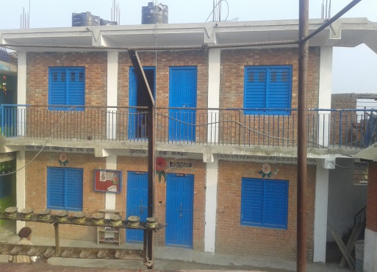  Completed building of Chittapol | 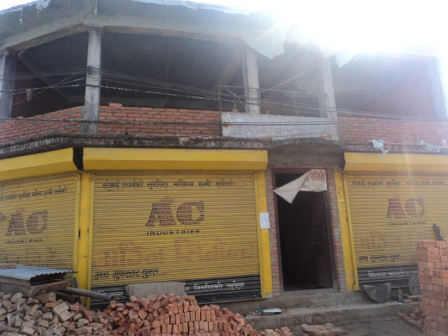  Siddhipur CLC with 2nd floor | 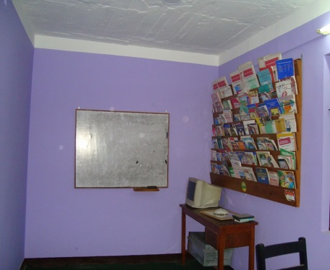  Painted Kumbheshwor CLC

5. Relief materials distribution
Apart from the above supporting activities to the earthquake victims, NRC-NFE has distributed warm clothes from the budget of "NRC-NFE's Earthquake Relief Fund". The materials distributed were flooring mats, blankets, trousers, woolen caps and Jackets. The CLCs distributed those materials to the selected needy earthquake victims families of the community. As reported by the CLCs, the materials were distributed to the children, old people, pregnant women and other needy people.
Description of the materials provided to the CLCs/ communities is given below :
CLC | Blanket | Woolen caps | Trousers | Jacket | Mat (metres)
Amarapur | 100 | 50 | 50 | 15
Chitapole | 150 | 50 | 105 | 15
Kumbheshwor | 40 | 40 | 15 | 15
Siddhipur | 150 | 43 | 30 | 15 | 75
Total | 440 | 183 | 200 | 60 | 460
Elders' group wearing jacket, Chittapol CLC | 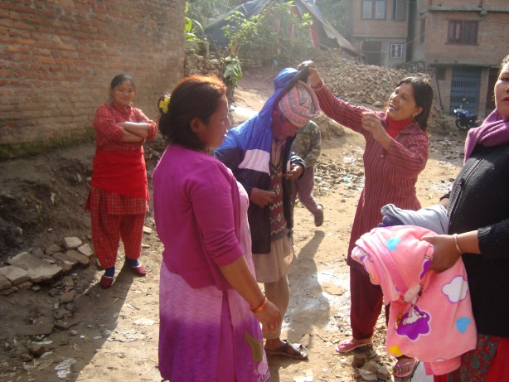  Jackets and blankets distribution, Kumbheshwor CLC
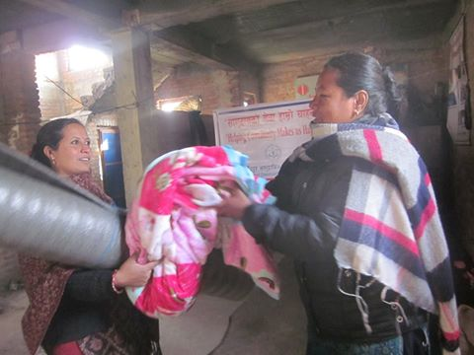  Mat and blanket distribution, Siddhipur CLC | 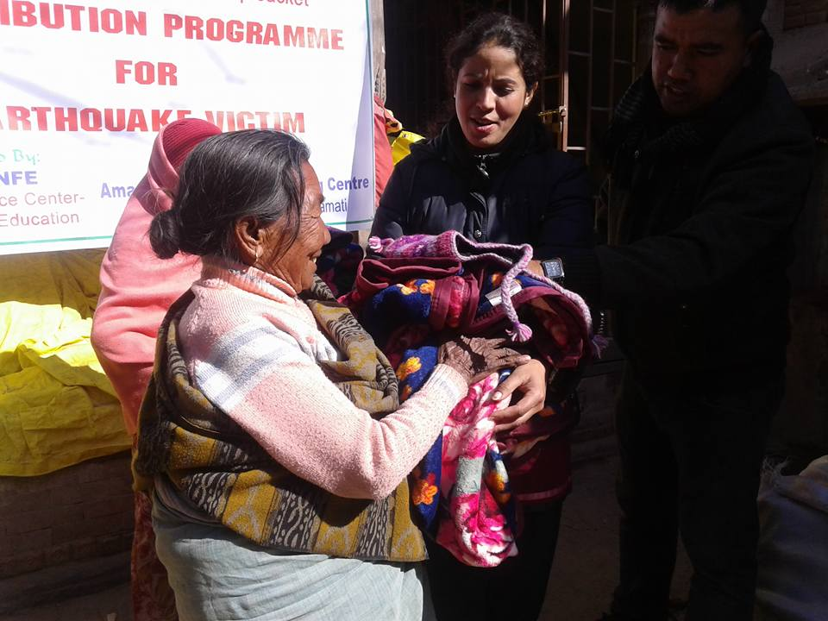  Blanket distribution, Amarapur
Annex I
Action plans of CLCs for PERP
Attached in separate spreadsheets

Annex II
Training on chlorine production using Standard Wata
Schedule
Time | Topics
10:30 – 11:00 | Registration
11:00 – 11:30 | Self-Introduction / objective of program
11:30 – 12:00 | Introduction to different Water Borne Diseases/Role of Chlorine Solution in water disinfection.
12:00 – 01:00 | Introduction to WATA  Application of WATA  - Preparation of brine  - Connection of equipment  - Precautions
01:00 – 01:45 | Lunch Break
01:45 – 02:45 | Methods of testing potable water  - Test of Chlorine Concentrate  - Residual Chlorine Test
02:45 – 03:30 | Distribution System of Chlorine solution /Marketing Skills
03:30 – 04:00 | Discussion on follow up program

List of participants
SN | Name of participants | CLC/ Organization | Designation
 | Rajana Maharjan | Amarapur CLC | CLC Manager
 | Yamuna Bajracharya | Amarapur CLC/ Female Friends Space (FFS) | Volunteer
 | Bikesh Maharjan | Amarapur CLC/ AdarshaSaulaYubak School | Student of grade 8
 | Sujeeta Bramharcharya | Amarapur CLC/ AdarshaSaulaYubak School | Student of grade 7
 | Mana Shova Twati | Chittapol CLC | CLC Manager
 | Shila Maka | Chittapol CLC | Program Coordinator
 | Sumina Twati | Chittapol CLC/ Shree Deuja LSS | Student of grade 7
 | Ayushi Twati | Chittapol CLC/ Shree Deuja LSS | Student of grade 7
 | Anjali Shahi | Kumbheshwor CLC | Manager
 | Sabina Shakya | Kumbheshwor CLC | Social Mobilizer
 | Namrata Thapa | Kumbheshwor CLC/ Kumbheshwor Technical School | Volunteer
 | Rita Sika | Kumbheshwor CLC/ Shree Kumbheshwor HSS | Student of grade 5
 | Pratima Katuwal | Kumbheshwor CLC/ Shree Kumbheshwor HSS | Student of grade 7
 | Sabina Maharjan | Siddhipur CLC | Manager
 | Shova Maharjan | Siddhipur CLC | Social Mobilizer
 | Lajana Maharjan | Siddhipur CLC/ Shree Siddhi Mangal HSS | Student of grade 9
 | Anjali Maharjan | Siddhipur CLC/ Shree Siddhi Mangal HSS | Student of grade 9
 | Shanti Shakya | NRC-NFE | Program Officer
 | Sukra Raj Maharjan | NRC-NFE | Program Officer
 | Kalyani Shrestha | NRC-NFE | Sr. Program Officer
 | Bimal Chitrakar | Observer participant | Trainer
 | Prasansha Shakya | Observer participant, Araniko Boarding School, Kathmandu | Student of grade 8

Resource Person
SN | Name | Organization with Address | Designation
 | Manisha Godar | Environmental Camps for Conservation Awareness (ECCA), Nepal | Program Assistant
 | Shailena Sthapit | Environmental Camps for Conservation Awareness (ECCA), Nepal | Program Assistant

Annex III
Training on Counseling
Schedule
Time |  | Day I
10:00 | 11:00 | Participants introduction/ group division/ norms setting/ weather chart/ job chart/ morning meeting
11:00 | 11:30 | Program introduction/ objectives
11:30 | 1:00 | Life skill (goal setting, confidence building, communication)
1:00 | 1:30 | Lunch break
1:30 | 2:00 | Tracing/ mask making
2:00 | 3:00 | Cooperation/ leadership/ team building activity
3:00 | 4:30 | Wall comic
4:30 | 5:00 | Wrap up
 |  | Day II
10:00 | 11:00 | Review of day I / job/ weather chart/ morning meeting
11:00 | 1:00 | Psychological activity I
1:00 | 1:30 | Lunch Break
1:30 | 2:30 | CLC stakeholder role and responsibilities
2:30 | 4:30 | Psychological activity II
4:30 | 5:00 | Wrap up and discussion on follow up program

Details of the contents
- Counseling for victims
- Counseling and its steps
- Counselor check list
- Different activities on different skill (observation skill, listening skill, active/ passive skill, paraphrasing, reflection of feeling)
- Life skill (goal setting, confidence building, communication)
- Co-operation, leadership and team building
- Psychological activities
- Post-traumatic stress disorder and its check list
- CLC stakeholders’ roles and responsibilities
- Follow up program/ activities plan
List of Participants
SN | Name of participants | CLC/Address | Designation
 | Rajana Maharjan | AmarapurCLC,Bungamati | Manager
 | Rita Maharjan |  | Volunteer
 | Sushila Shakya |  | CLCMC member
 | Purna Maya Mali |  | CLCMC Member
 | Surendra Maharjan |  | Volunteer
 | Mira Thapa Shah |  | CLCMC Member
 | Mana ShovaTwati | Chittapole CLC, Bhaktapur | Manager
 | Indra Nagarkoti |  | CLCMC member
 | Nirmal Maka |  | CLCMC Member
 | Tulasha Deuja |  | CLCMC Member
 | Sulochana Maka |  | volunteer
 | Anita Twati |  | volunteer
 | Anjali Shahi | Kumbheshwor CLC, Kumbheshwor | Manager
 | Jarina Khadgi |  | Chairperson
 | Shanta Laxmi Khadgi |  | Tresurer
 | Safalta Khadgi |  | CLCMC Member
 | Sarmila Khadgi |  | CLCMC member
 | Bhawana Khadgi |  | volunteer
 | Sabina Maharjan | Shiddhipur CLC, Shiddhipur | Manager
 | Shova Maharjan |  | Social Mobilizer
 | Gyani Maharjan |  | CLCMC Member
 | Ram Chandra Maharjan |  | CLCMC Member
 | Ambika Maharjan |  | volunteer
 | Laxmi Maharjan |  | volunteer
 | Resource persons
 | Mr. Siddhi Bahadur Bajracharya | ECCA | Trainer
 | Ms. Palistha Sikharakar | ECCA | Facilitator

Annex IV
Training on awareness program on Disaster Risk Reduction (DRR)
Schedule
Time |  | Program
11:00 | 11:30 | Registration/ participants introduction
11:30 | 1:30 | Presentation and discussion on disaster/ earthquake risk deduction, disaster preparedness and rescue and its management
1:30 | 2:00 | Lunch Break
2:00 | 3:00 | Community based different awareness program and activities on earthquake
3:00 | 4:30 | Presentation and discussion on primary health care and use of First Aid  Discussion on follow up program plan

Details of contents
- Earthquake, its causes and effect
- Different technique of earthquake risk deduction, preparedness and rescue
- Nepal earthquake and lack of awareness
- Safe and unsafe places
- Prepared for emergency materials (individual, house hold, institution and community)
- Planning for information communication center, contact places after earthquake
- Management of earthquake resistant houses
- Primary health care/first aid and its different steps
- Physical examination of health
  - Psychological support and counseling
  - Follow up program/activities plan

Action plan of awareness and counselling activities of CLCs are as follows:

Nepal Post Earthquake Relief Project, 2015-17
Amarapur CLC
Counseling and Awareness Program Plan
SN | Activities | Target group | Venue | Date | participants | Materials | Responsibility | Budget
1 | Video Show (4 times) | Community people | Chole Nani-10, Machhindra Bahal-11,  VDC Hall- 12, Chunni Devi LSS-13 | 19 Feb 016,  5 Mar 016, 19 Mar 016, 25 Mar 016 | 50,  50,  50,  50 | Earthquake Risk Reduction and preparedness –CD, Projector | Chairman, Manager
2 | Orientation on natural disaster risk management  (4 times) | community people, students, youth, CLCMC | VDC Hall - 12, | Mid Feb to Mid-Jun 016 | 30 * 4 | NSET powerpoint, Booklets on Earthquake Risk eduction, Posters, Video | Chairman, Manager
3 | Reading session and discussion progrm on earthquake education | learners of Post Literacy classes, mothers groups, women groups, saving and credits groups (10 times) | Post Literacy classes, wards no 11,12, VDC Hall | Mid Feb to Mid-Jun 016 | 20* 10 | Booklets on Earthquake Risk Reduction, Posters, Video | Manager, facilitators
4 | Art competition & exhibition on earthquake | School Students | CLC Building and exhibition on differnet places | 24 April 016 | 30 | Chart Paper, Marker Pen, Sign pen etc | Chairman, Manager
5 | Role play on earthquake risk management | students from class 5-9 | Khalba 12 | 27 Feb 016 | 25 |  | Manager, Mira
6 | Goal setting | students from Grade 5-9 | world vision office, Khalba-12 | 26 Mar 016 | 25 | Guidelines of games and required materials | Manager, Rita Maharjan
7 | Ball Pass Game | community women (2 times) | world vision office, Khalba-12 | Mid April 016 | 50 | Guidelines of games and required materials | Manager, Surendra Maharjan
8 | Game ( Kaam Pass) | Members of Amarapur Children Club | VDC Hall- 12, | 9 Apr 016 | 25 | Guidelines of games and required materials | Manager, Purna Maya
Prepared on 16 Feb 2016
Nepal Post Earthquake Relief Project, 2015-17
Siddhipur CLC
Counseling and Awareness Program
SN | Activities | Target group | Venue | Date | participants | Materials | Responsibility | Budget
1 | Video Show (3 times) | Community people, Students | old CLC- 13,  new CLC- 12, Shiddhi Mangal School-14 | 27 Feb 016, 26 Mar 016, 27 Apr 016 | 50,  50,  50 | Video of earthquake of Shiddhipur,Earthquake Risk Reduction and preparedness –CD | Manager, social manager
2 | Art competition on earthquake | School students | School  (Exhibition on various areas) | 24 April 016 | 30 | Chart papers, pencils, and colors | Manager, Social mobiizer
3 | Interaction on disaster risk reduction management | Community | New CLC building | March to Mid-April 016 | 30 | Presentation paper | Chairman
4 | Reading session on earthquake in Post LINEM and Continuing Classes | Learners of Post LINEM and Continuing Education classes (14) | PL and CE classes | Mid-Feb to Mid Jun 016 | 20 *14 | Booklet on Earthquake Risk Reduction, posters and video | Manager, Social mobilizer
5 | Goal setting | students from Grade 5-6 | Shiddhi Mangal School | Last week April 016 | 30 | Games and required materials | Ram Chandra & Laxmi
6 | Role play on earthquake risk management | Learners of CE (DEO-2+NRC-2) | CE classes | Mar to Mid Apr 016 | 80 | Activity guidelines | Ambika, Gyani
7 | Kaam Pass ( Game) | Children form Kopila Nepal | Kopila Nepal | Mid-Mar 016 | 20 | Guidelines of game and materials | Manger, Social mobilizer
8 | Ball Pass Game | community women (3 times) | New CLC Building | Mid-May 016 | 90 | Guidelines of game and materials | Manger, Social mobilizer
Prepared on 15 Feb 016
Nepal Post Earthquake Relief Project, 2015-17
KumbheshorCLC
Counseling and Awareness Program
SN | Activities | Target group | Venue | Date | participants | Materials | Responsibility | Budget
1 | Video show on Earthquake Risk Reduction and preparedness ; Orientation on First Aid Treatment | Community ( 2 times) | KholchhaPokhari -22, Chakupat- 22 | 17 Jan 016, 3 Mar 016 | 40 | Earthquake Risk Reduction and preparedness- CD through Projector | Manager
2 | Reading session and discussion on earthquake (DEO-12+NRC-3) | learners of Continuing Education classes (15 times) | CE classes in different places | Mid-Feb to Mid-Jun 016 | 20 *14 | Booklets on Earthquake Risk Deduction, Video, Poster | Manager
3 | Class on counseling service | Group Leaders, community ( 2 times) | Kholcha Pokhari -22 | Mid-Mar 016 | 50 | Meta Cards, Multimedia | Manger, Shanta
Prepared on 18 Feb 016

Nepal Post Earthquake Relief Project, 2015-17
Chittapol CLC
Counseling and Awareness Program
SN | Activities | Target group | Venue | Date | participants | Materials | Responsibility | Budget
1 | Orientation on First Aid Treatment | Group leaders, facilitators | CLC Office-12 | Mid-March 016 | 30 | First Aid Treatment book, First aid box | Manager, Tulasha Deuja
2 | Video show (3 times) | Community, School students | CLC Office-12, Daha Gaun Primary School-13,  Baal Sikshya Sadan-Sallaghari-14 | Mid-Feb to Mid-May 016 | 50*3 times | Video of earthquake of Bhaktapur area, Earthquake Risk Reduction and preparedness-CD | Manager, Shila
3 | Interaction on Disaster Risk Reduction management | Community stakeholders | CLC Building-12 | Mid-April 016 | 30 | Presentation paper | Chairman, Manager
4 | Reading session and discussion on earthquake (DEO-10+NRC-3) | learners of Continuing Education classes (13 times) | CE classes in different places | Mid-Feb to Mid-Jun 016 | 20 *13 | Booklets on Earthquake Risk Deduction, Video, poster | Manager, Social mobilizer
5 | Goal setting | Students of grade 5 & 6 | Baal Sikshya Sadan-Sallaghari | Mid-April 016 | 30 | Guidelines of activity and chart papers | Sila and Nirmal
6 | Ball Pass (Games) | Groups | CLC Building-12, Nagarkoti Tole Thasi tar | Mid-April to Mid-May 016 | 30 | Guidelines of game and related materials | Manager, Indra Bahadur, Tulasha, Sulochana
7 | Story telling (Who Am I ? ) | Facilators of Continuing Education classes and group leaders | CLC Building-12, | Mid- Mar 016 | 20 | Guidelines of activity | Manger, Anita
Prepared on 19 Feb 016

Annex V
Descriptions of students for scholarship
S.no | CLC | Name of Beneficiaries | Grade/Class | Remarks
 | Amarapur | - Sijan Maharjan | 6 | 10 children
 |  | - Deepika Tuladhar | LKG
 |  | - Ritesh Maharjan | 5
 |  | - Aryan Maharjan | 2
 |  | - Avinash Waiba Tamang | 5
 |  | - Krish Maharjan | LKG
 |  | - Biswas Desar | 1
 |  | - Bijaya Desar | 1
 |  | - Manila Nijananda | 1
 |  | - Sarina Shakya | 3
 | Chittapol | - Pawan Karki | 6 | 9 children
 |  | - Manik Twati | 7
 |  | - Suchita Suwal | 9
 |  | - Saraswoti Newpane | 8
 |  | - Sahil Bujel | 2
 |  | - Saraswoti Twati | 12
 |  | - Ranju Dulal | 8
 |  | - Sarita Dulal | 5
 |  | - Swastika Ranamagar | 3
 | Kumbheshwor | - Sujal Khadgi | 2 | 5 children
 |  | - Sewika Shakya | 1
 |  | - Mira Khadgi | 8
 |  | - Atisha Shrestha | LKG
 |  | - Roshani Shahi | 9
 | Siddhipur | - Asish Maharjan | LKG | 15 children
 |  | - Kusal Nemkul | LKG
 |  | - Lakisha Maharjan | 2
 |  | - Aayush Maharjan | 9
 |  | - Subham Maharjan | 2
 |  | - Sumit Maharjan | 3
 |  | - Sosana Maharjan | 6
 |  | - Ganga Nemkul | 3
 |  | - Jamuna Nemkul | 3
 |  | - Kirti Maharjan | 9
 |  | - Asal Maharjan | 8
 |  | - Rashila Maharjan | Nursery
 |  | - Niroj Awale | 9
 |  | - Sujan Maharjan | 7
 |  | - Priya Maharjan | Nursery

