Case stories
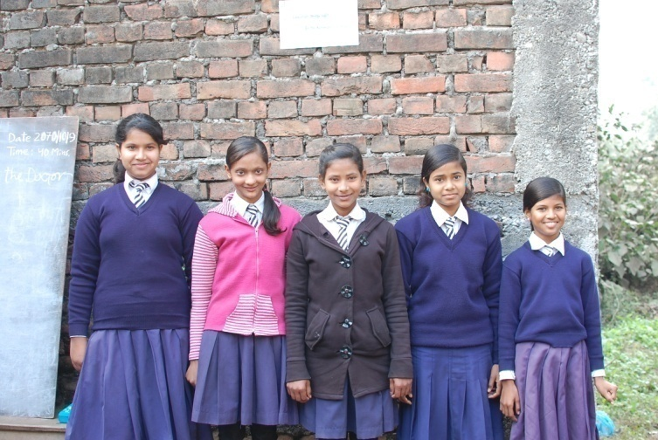
Bina Harijan - From FSP to Boarding School

Bina Harijan, daughter of Ram Lakhan Harijan, is studying in grade six in Buddha Light English boarding school. She joined the school after completion of 3 levels of FSP organized by Bhagwanpur CLC at CLC's own building. The school she is studying is located at a distant of 15 minutes walk from her home. She has to pay 550 per month against tuition fee in addition to 300 annual fees, 200 for tie and belt and 600 for exams. She has chosen boarding school although it is expensive for her family because she wants to have good quality education from English medium boarding school as she wants to become a doctor in future. So, her favorite subject is science which is base for medical line.

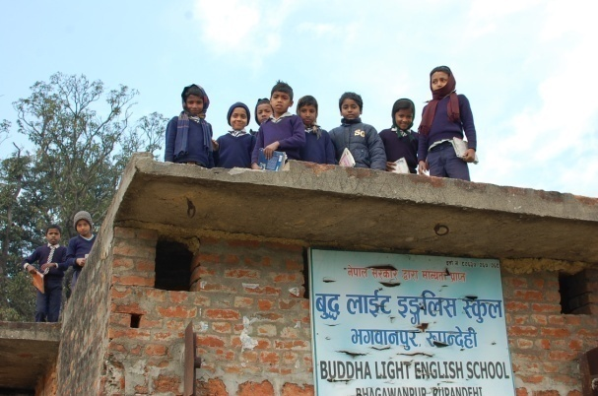
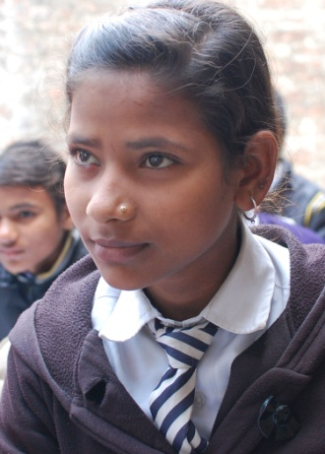
She is not satisfied with the condition of school such as class rooms are not maintained, her class room is without roof, no toilet facility. However she is satisfied with the education she is getting from the dedicated teachers and principal. The principal Mr. Harijan is his own father. It is wondering that daughter of principal of boarding school was out of school. Mr. Harijan was unable to send his daughter to school. But the FSP organized by CLC had been great opportunity for Harijan family to provide education to their daughter Bina Harijan. So, Mr. Harijan and Ms. Bina Harijan are very happy with CLC and grateful to the support of NFUAJ for CLC programs through NRC-NFE.
