Bina B K's dream – to be a teacher

Bina BK (Sunar) is very happy that she graduated from Grihini Sichhya organized by Rajpur CLC. She completed 3 years course of adult primary education (Grihini Sichhya) in July 2013. She learned a lot from 3 years. She became more confident to speak out and express own opinion in mass. She also learned some English. She can read and get information from sign boards, posters, pamphlets while travelling and visiting hospitals and agriculture service centers. She became able to handle family budget and make loan interest calculation.

Bina is very much interested to continue her education. Her target is to complete lower secondary level of 2 years and secondary level of 1 year education from non formal adult school operated by Rajpur CLC. Bina and her 15 classmates are very fond of learning and getting further education of 3 years after which they can attempt SLC exam. Bina dreams to be a teacher in primary school after SLC. Let's wish for her dream come up to real.

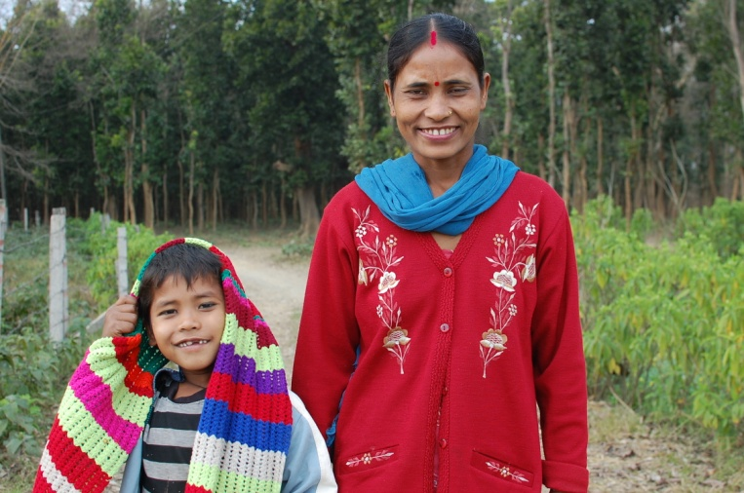
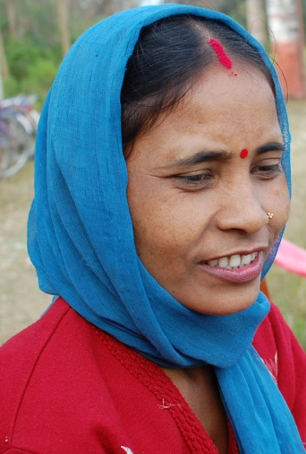
She has a son of 4 years old who is studying in ECD class. Her husband does not earn much. Bina is helping to manage the family budget. She is earning money by constructing improved stove for others. After receiving 7 days technical training on constructing improved stove from an NGO called Mt Everest in Kopawa, she became a technical person in the community. She could participate in the training as she had acquired literacy skills from Grihini Sichhya. She can make 5 types of improved stove which are smokeless, less firewood consuming and so environment friendly. She has constructed about 150 stoves so far. It costs about 750 for a stove including 250 for equipments and 500 for charge for technician, if the beneficiary manages bricks and mud for structure. She gets Rs. 500 per stove from the beneficiary household. Last year, she constructed 80 stoves from which she could earn about 40,000. She's got rocket stove for her home. This way she is working for ESD promotion in her community at her own level.

